CZ1115 Lecture ONE

HISTORY, STATE-OF-THE-ART

AI = intelligence demonstrated by machines. Contrast with natural intelligence (NI) by humans/animals.

## Founding Fathers of AI

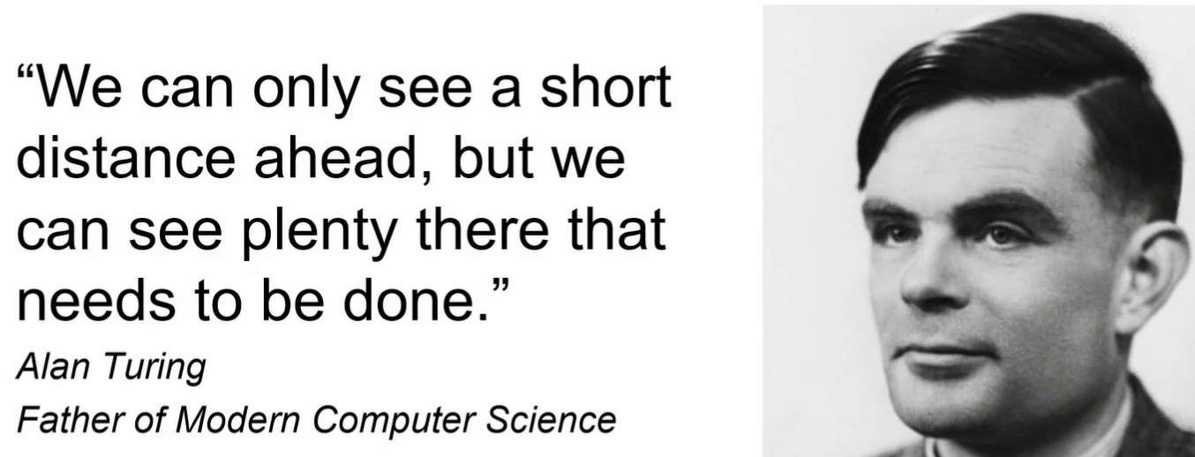

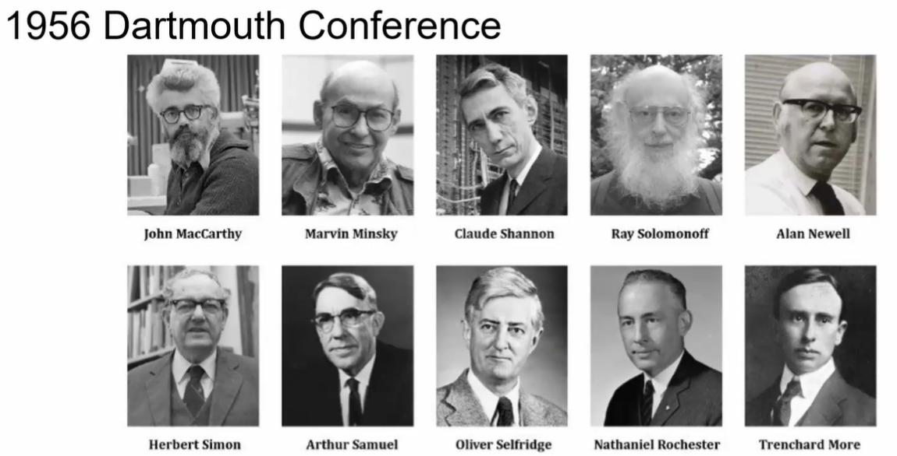

# History

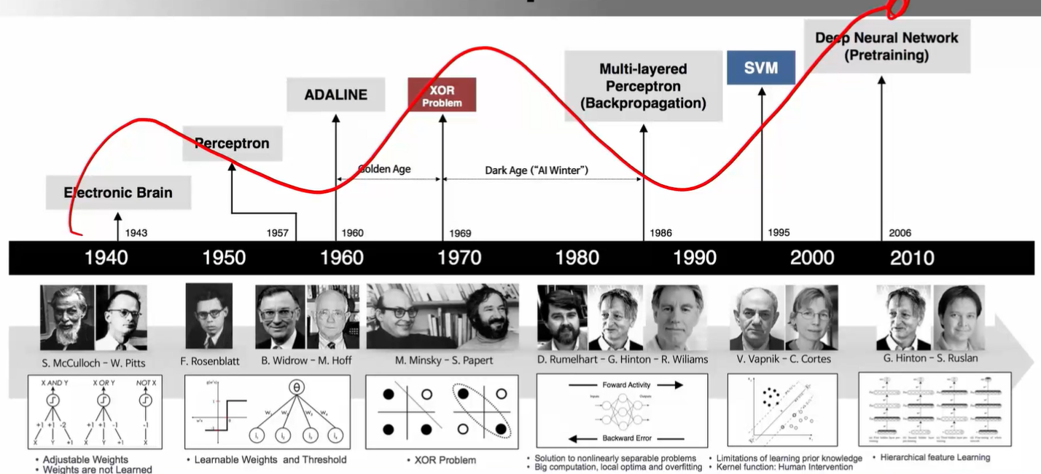

now AI research is powered by private companies

# Games

## Computer Chess

* Deep Blue vs Garry Kasparov, 1997
* Beat world champion in chess. Based on advanced search algorithms

## Robot Soccer

* Goal: create a team of robots to beat the best team in the world

## Jeopardy

* IBM’s Watson beat players in Jeopardy (host give answer, participants give question)
* Watson not doing very well in healthcare though
* AI has progress, but progress not as significant as expected

## Go

* DeepMind’s AlphaGo win against world champions. Google bought it. Deep learning
* 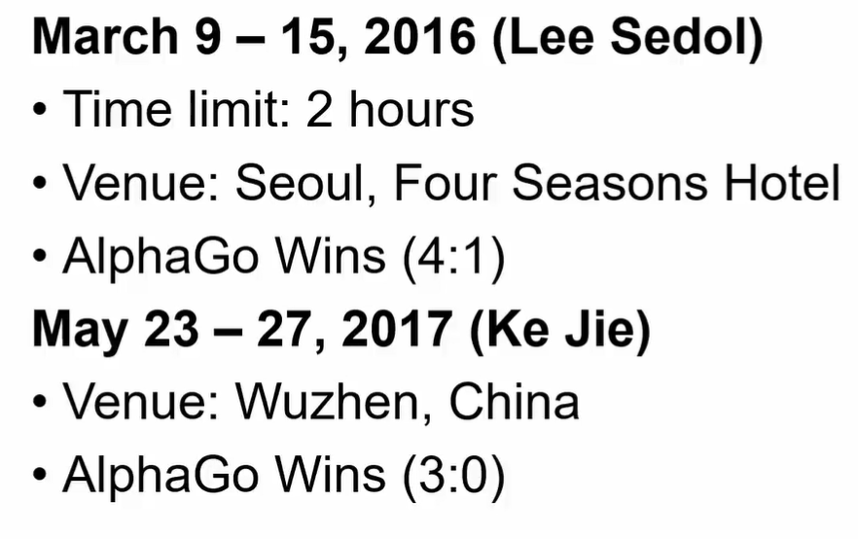

## Poker

* Incomplete information game: you don’t know your opponent’s hand unlike Go
* Libratus: first AI to defeat top human poker players
* Nothing to do with deep learning: algorithms for solving large scale games

# Teknologi

## Google Driverless Car: autonomous driving

* “impossible in the next 10 years”

## Google Robot Dog: Boston Dynamics

## Natural Language Processing: Alexa, Google Assistant, Cortana, Siri

## Manufacturing: Tesla

## Finance:

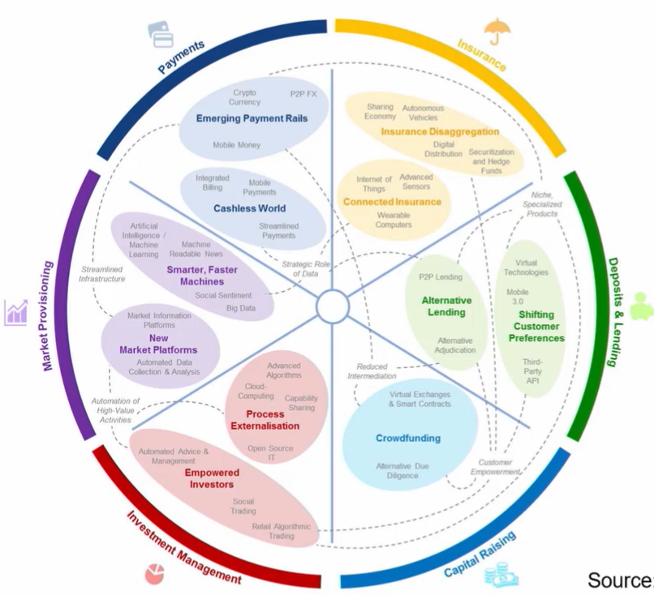

# Next:

## Stochastic, open environment. E.g. Starcraft

## Multiple players. Robots need to communicate with each other. E.g. soccer

## Sequential decision, online. E.g. soccer

## Strategic (selfish) behaviour.

## Distributed optimisation.

# Views of AI fall into four categories:

|  |  |
| --- | --- |
| 1. Thinking Humanly | 3. Thinking Rationally |
| 2. Acting Humanly | **4. Acting Rationally <-- CS’ focus area** |

## 1. Thinking Humanly: Cognitive Modelling

* “Cognitive revolution”: information-processing psychology (1960s)
* Requires scientific theories of internal activities of the brain.
* Research by congitive neuroscientists

## 2. Acting Humanly: Turing Test

* Operational test for intelligent behaviour: the Imitation Game (Turing, 1950, “Computing Machinery and Intelligence”)



* Components of AI: knowledge, reasoning, language understanding, learning
* CAPTCHA: Completely Automated Public Turing Test to Tell Computers and Humans Apart. A reverse Turing Test (administered by a bot)

## 3. Thinking Rationally: “Laws of Thought”

* Correct arguments/thought processes. (Aristotle)
  + Several Greek schools developed various forms of logic: notation and rules of derivation for thoughts. May have proceeded to the idea of mechanisation
* Direct line through mathematics and philosophy to modern AI.
* Problems: not all intelligent behaviour is mediated by logical deliberation.
  + What is the purpose of thinking?
  + What thoughts should I have?

## **4. Acting Rationally: Rational Agents**

* Rational behaviour: doing the right thing - that which is expected to maximise goal achievement given the available information.
* Design rational agents, and seek agents with the best performance for any given class of environments and tasks.

CZ1115 Lecture TWO

INTELLIGENT AGENTS

1. Problem formulation via an agent: percepts, actions, goals, environment.
2. Use a search technique to find the solution to the above problem

# Agent

## an entity that

* perceives through sensors (e.g. eyes, ears, cameras, infrared range sensors)
* acts through effectors (e.g. hands, legs, motors)

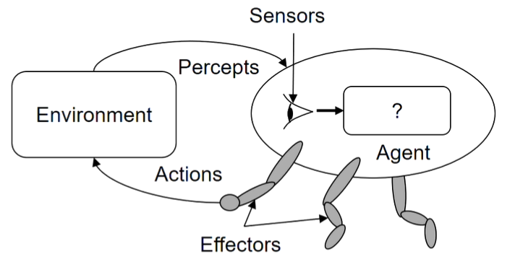

# Rational Agents

## one that does the right thing

* Rational action: action that maximises the expected value of an objective performance measure given the percept sequence to date
* Rationality depends on
  + performance measure
  + everything that the agent has perceived so far
  + built-in knowledge about the environment
  + actions that can be performed

Example: driverless vehicle / application

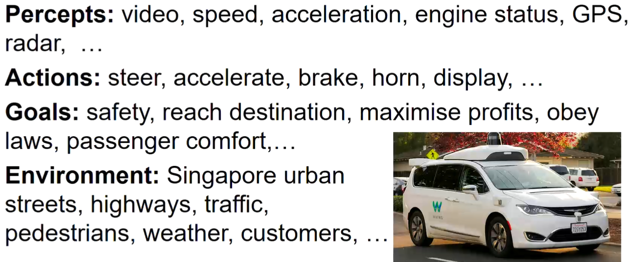

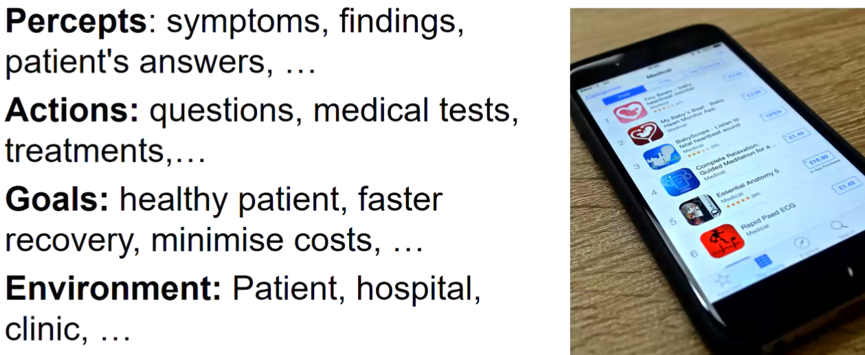

# AUTONOMOUS AGENTS

## Does not rely entirely on built-in knowledge about the environment (i.e. not entirely pre-programmed)

* (Otherwise, agent will only operate successfully when the built-in knowledge are all correct)
* Adapts to the environment through experience.

Example: driverless car learning to drive in various places

# Simple Reflex Agents

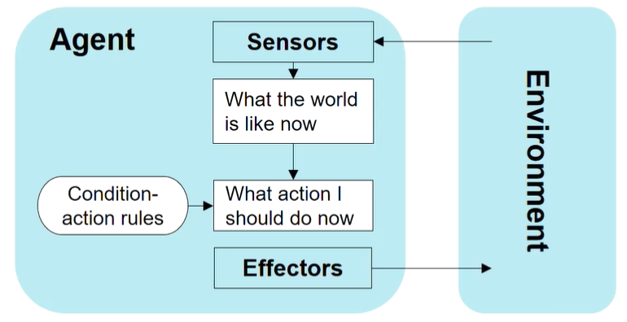

1. Find the rule whose condition matches the current situation (as defined by the percept)
2. Perform the action associated with that rule

# --> Reflex Agents with State

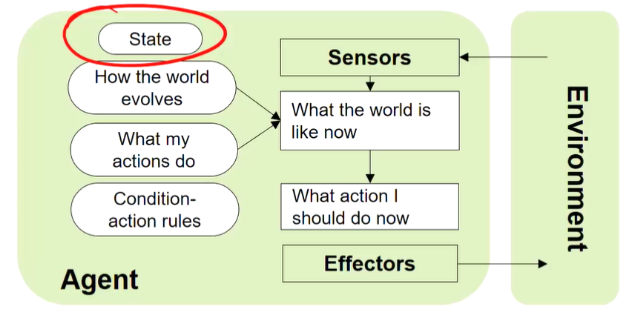

* Like the above but now current situation is percept AND **stored internal state** (e.g. info about yesterday)

# Goal-Based Agents

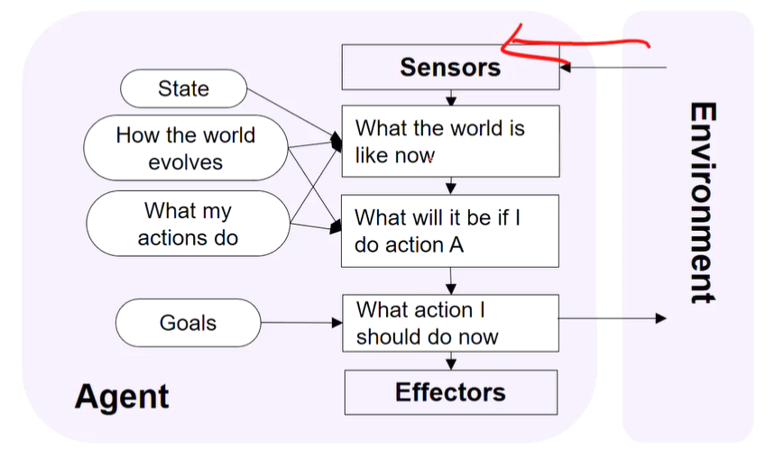

* Needs some sort of goal information.

# --> Utility-Based Agents

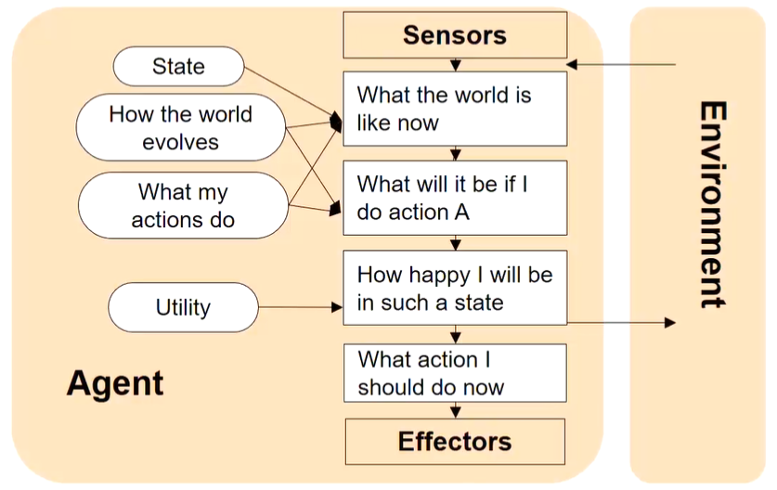

* There may be many action sequences that can achieve the same goal. Which should it take?
* Like the above but has a utility function: how happy will an agent be if it attains a certain state?

# TYPES OF ENVIRONMENTS

## Accessible (vs inaccessible)

* Agent’s sensory apparatus gives it access to the complete state of the environment
* e.g. Go (vs Poker)

## Deterministic (vs nondeterministic)

* Next state of the environment is completely determined by the current state and the actions selected by the agent
* e.g. Go & Poker: turn-based (vs autonomous driving & robot soccer: many other agents at simultaneous play)

## Episodic (vs sequential)

* Each episode is not affected by the previous taken actions
* e.g. Rock Paper Scissors??? (vs Go & Poker)

## Static (vs dynamic)

* Environment does not change while an agent is deliberating
* e.g. Chess (vs autonomous driving & robot soccer)

## Discrete (vs continuous)

* Limited number of distinct percepts and actions
* e.g. Chess & Go (vs autonomous driving)

Driverless vehicle

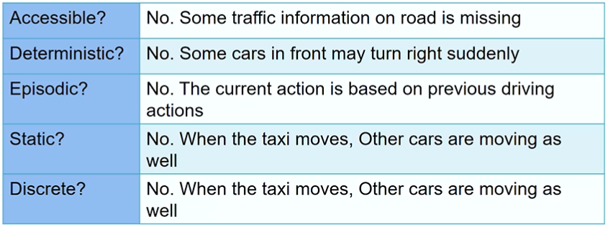

Chess

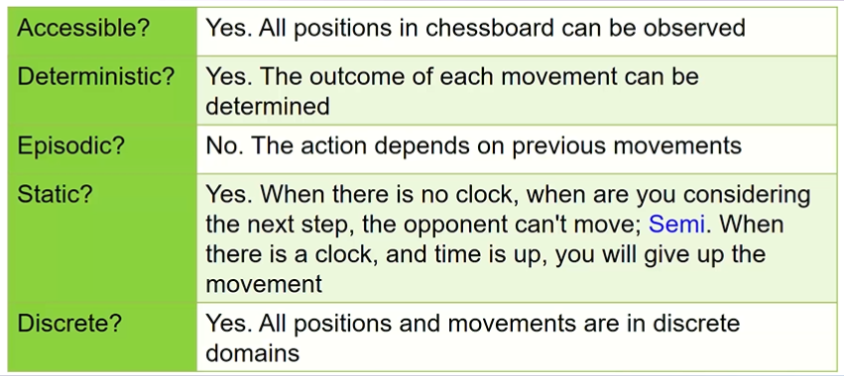

Minesweeper

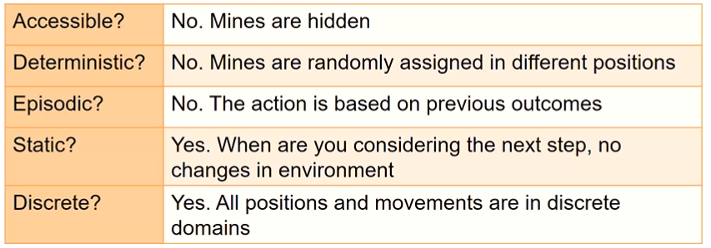

Slot machines

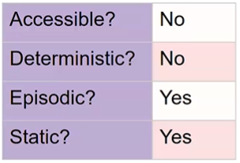

# Design of Problem-Solving Agent

## Idea

* Systematically considers the expected outcomes of different possible sequences of actions that lead to states of known value.
* Goal: Shortest journey from A to B? Most cost effective journey from A to B?

## Steps

1. Goal formulation
2. Problem formulation
3. Search process
   1. No knowledge --> uninformed search
   2. Knowledge --> informed search
4. Action execution (follow the recommended route)

# WELL-DEFINED FORMULATION

## Problem definition: information used by an agent to decide what to do

## Specification

* Initial state
* Action set i.e. available actions (successor functions)
* State space i.e. states reachable from the initial state
  + Solution path: sequence of actions from one state to another
* Goal test predicate
  + Single state, enumerated list of states, abstract properties
* Cost function
  + Path cost g(n), sum of all (action) step costs along the path

## Solution: a path (sequence of operators leading) from the initial state to a state satisfying Goal-test

# Measuring Problem-Solving Performance

## Search cost

* What does it cost to find the solution? Time/memory?

## Total cost of problem-solving = search cost (offline) + execution cost (online)

* Search a very long time for the optimal solution, or
* Search a shorter time for a “good enough” solution
* “Anytime search”: just-in-time search. Provide solution then think of next steps along the way.

Example: point A to B

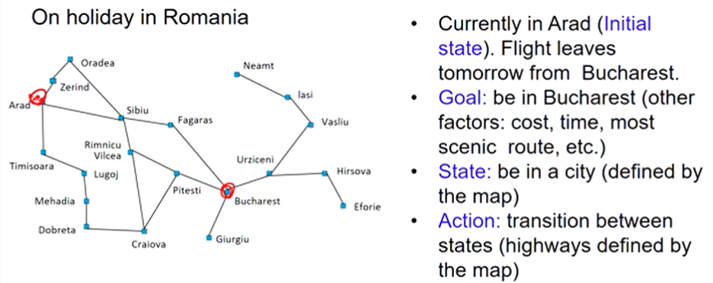

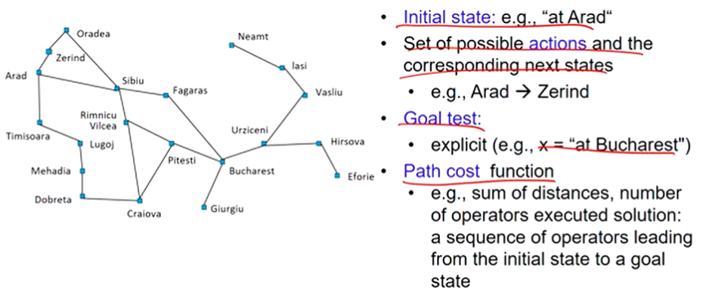

Example: Roomba vacuum

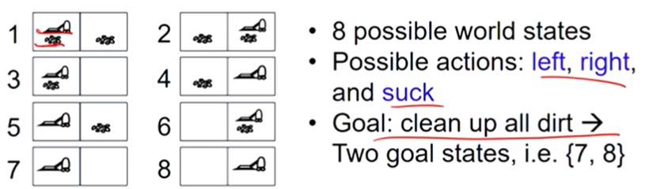

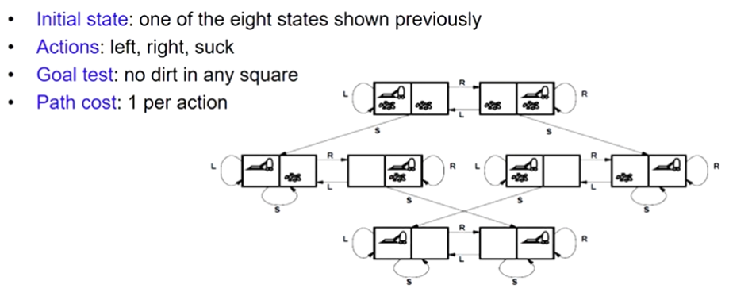

Example: 8-puzzle

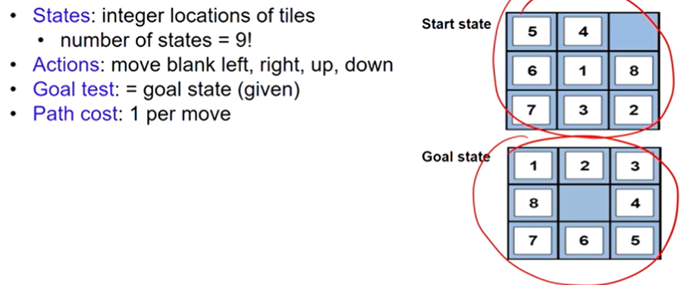

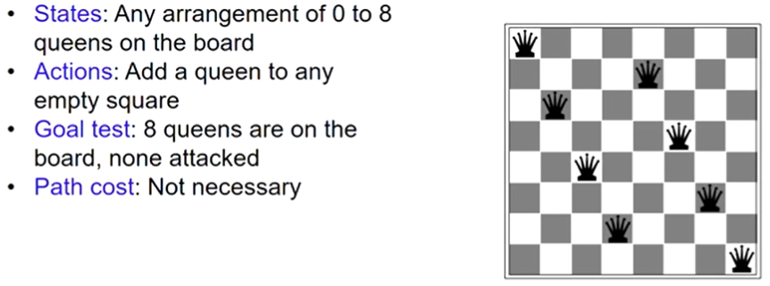

Other examples:

* Route finding problems: robot navigation, travel advisory, airline travel planning
* Touring problems: travelling salesman problem, “shortest tour”

CZ1115 Lecture THREE

SOLVING PROBLEMS BY SEARCH

Most AI problems can be treated as a search problem, e.g. autonomous driving (search for best path).

# Search Algorithms

## Exploration of state space by generating successors of already explored states

* Frontier: candidate nodes for expansion
* Explored set (nodes already explored)
  + We don’t really use this due to the large amount of memory needed

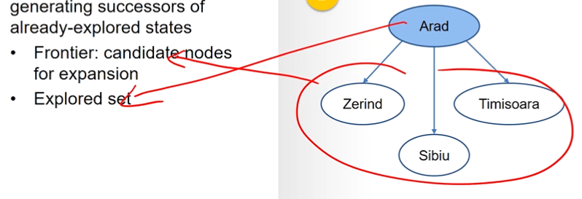

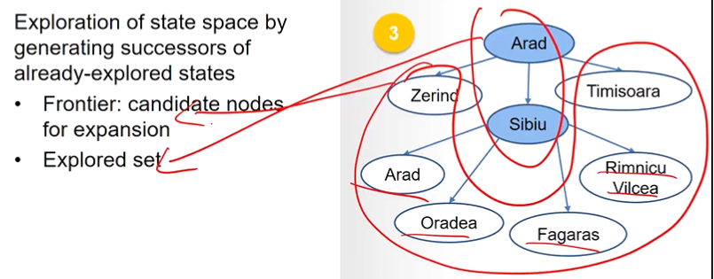

note #1: Arad is in both explored set and frontier. To avoid such repetition of expansion, there is additional offline cost.

note #2: Sibiu was expanded first. Different search algorithms may use different order to determine which node should be expanded first.

# Search Strategies

## Strategy is defined by picking the order of node expansion.

Strategies are evaluated along the following dimensions:

* Completeness
  + Does it always find a solution if one exists?
* Time complexity
  + How long does it take to find a solution: number of nodes generated?
* Space complexity
  + Maximum number of nodes in memory.
* Optimality
  + Does it always find the best (least-cost) solution?

## Branching factor

* Maximum number of successors of any node
* Or average branching factor

UNINFORMED SEARCH

## Use only the information available in the problem definition.

* Systematic generation of new states to reach goal test.
* Inefficient (exponential space and time complexity).
  + Breadth-first search
    - expand from the shallowest node down. If same level, then start from the left.
  + Uniform-cost search
    - expand from the shallowest node down. If same level, then expand the least path node.
  + Depth-first search
    - keep pushing deeper until we hit a dead end. If same level, choose the node with longest path ahead. When we hit dead end, backtrack until we can push again.
  + Depth-limited search
    - push deeper but with an artificially set limit on how deep to push.
  + Iterative deepening search
    - push deeper but with an artificially set limit on how deep to push. If goal state still not found, then increase the push limit.

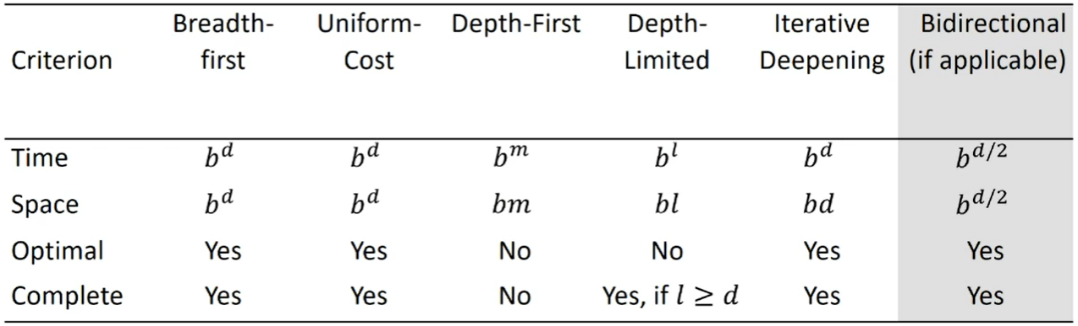

* For hypothetical state-space,
* b = maximum branching factor of the search tree
* d = depth of the least-cost solution
* l = limit of depth in depth-limited search
* m = maximum depth of any node

# UNF | Breadth-first search

## Expand shallowest unexpanded node which can be implemented by a FIFO queue

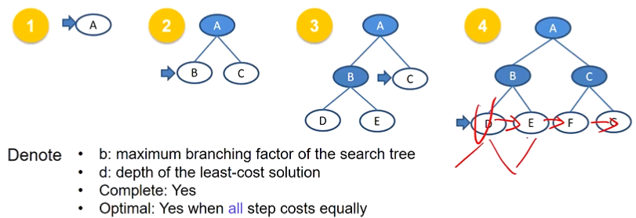

## Complexity of BFS

|  |  |
| --- | --- |
| Struct Type | FIFO queue |
| Complete | Yes |
| Time | 1 + b + b2 + b3 + ... + bd = O(bd), d=depth of the least-cost solution |
| Space | O(bd) (keeps every node in memory | memory size of frontier) |
| Optimal | Yes, if all step costs are equal (path cost is a non-decreasing function of the depth of the node) |

+ Will provide optimal and complete solution

– Requires lots of memory since each level of the tree must be saved to expand the next level

– Needs lots of time if solution is far away from the root node

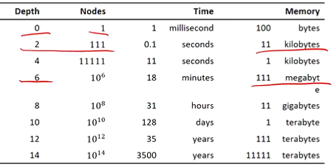

# UNF | Uniform-cost search

## To consider edge costs, expand unexpanded node with the least path cost g

* Instead of FIFO queue, use a priority queue with path cost g(n) to order the elements
* BFS = UCS with g(n) = Depth(n)

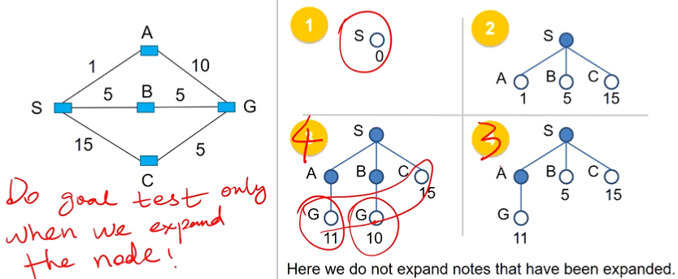

1. We find the least path cost node in the frontier. It is A in this case. We do a goal test on it.
2. If A is not goal, we expand it. Now the frontier is GBC.
3. *WE DO NOT CHECK FOR GOAL STATE AMONG THE FRONTIERS AT THIS STAGE. Instead,
4. Repeat step 1 --> do goal test on B
5. Repeat step 2 --> If B is not goal, we expand it. Now the frontier is GGC.
6. Repeat step 1 --> do goal test on G(10)
7. Repeat step 3 --> G is the goal! We stop here. The answer is SBG.

* *If we did the goal test when we add the node to the frontier, we would get SAG as the answer, which is wrong.

## Complexity of UCS

|  |  |
| --- | --- |
| Struct Type | Priority queue (path cost g(n)) |
| Complete | Yes |
| Time | O(bd)  # of nodes with path cost g <= cost of optimal solution  (equivalent number of nodes pop out from the priority queue) |
| Space | O(bd)  # of nodes with path cost g <= cost of optimal solution |
| Optimal | Yes |

+ Optimal, complete

– May get stuck in infinite loop

# UNF | Depth-first search

## Expand deepest unexpanded node with which can implemented by LIFO stack. Backtrack only when no more expansion.

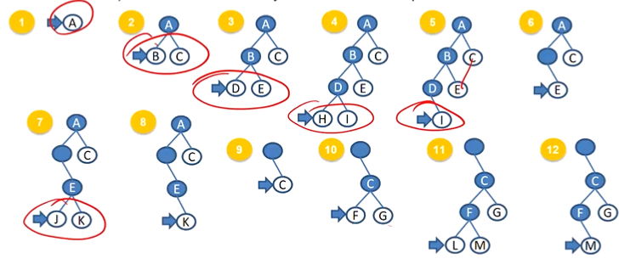

always try to expand deepest left node.

## Complexity of DFS

|  |  |
| --- | --- |
| Struct Type | LIFO stack |
| Complete | Generally No   * Infinite-depth spaces: No * Finite-depth spaces with loops: No * With repeated-state checking: Yes * Finite-depth spaces without loops: Yes |
| Time | O(bm), m=maximum depth of any node and can >> d (shallowest solution depth)  If solutions are dense, may be much faster than breadth-first |
| Space | O(bm) |
| Optimal | No |

+ Requires less memory as it only needs to store a stack of the nodes on the path from root node to the current node.

+ May take less time to reach goal node than BFS if it traverses in the right path

– Might end up in infinite loop

# UNF | Depth-limited search

## Like DFS but with a cutoff on the max depth / of a path. Resolves infinite loop issue from DFS.

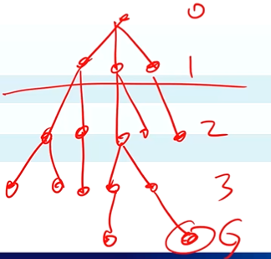

|  |  |
| --- | --- |
| Struct Type | LIFO stack |
| Complete | Yes, if l >= d |
| Time | O(bl) |
| Space | O(bl) |
| Optimal | No |

+ Memory efficient

– May be incomplete

– Not optimal if problem has more than one solution

# UNF | Iterative deepening search

## Like DLS but iteratively estimate the max depth. If cannot find solution, max depth++

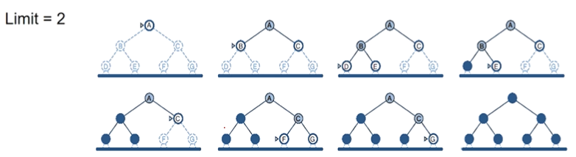

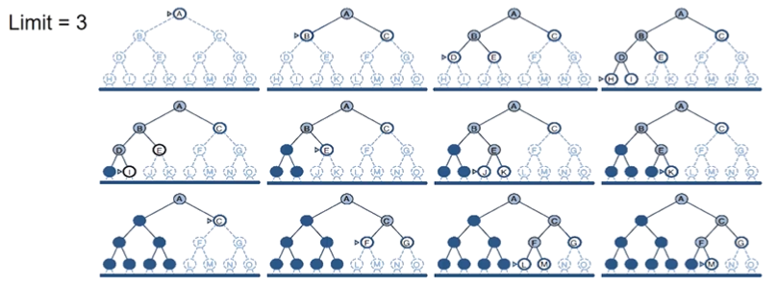

|  |  |
| --- | --- |
| Struct Type | LIFO stack |
| Complete | Yes |
| Time | O(bd) |
| Space | O(bd) |
| Optimal | Yes |

+ Combines BFS and DFS in terms of fast search and memory efficiency

– Repeats all the work of the previous phase

# INFORMED SEARCH

## Use problem-specific knowledge to guide the search. Usually more efficient.

* Use problem-specific knowledge to decide order of node expansion
* Best First Search: expand the most desirable unexpanded node. Use an evaluation function to estimate the “desirability” of each node.
  + Greedy search
    - Expand node with smallest h(n)
  + A* search
    - Expand node with smallest h(n)+g(n)

## **Evaluation Function**

* **Path-cost function g(n)**
  + cost from initial state to current state (search-node) n.
  + No information on cost toward the goal!

|

| Need to estimate cost to the closest goal.

| 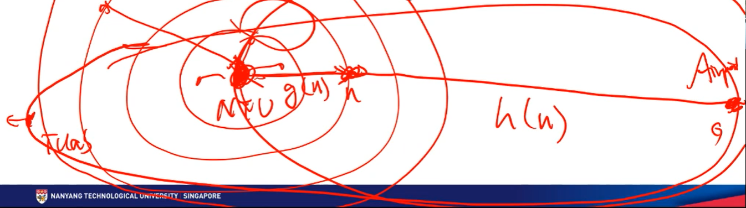

| Say we want to go from NTU to Airport.

| Uniform cost search UCS (uninformed) will just naively expand radially from NTU, even Westward towards Tuas.

| This doesn’t help, because we know for a fact that we should be going East.

| Hence, we add a heuristic function h(n) that gauges how far the nodes are to the goal.

| In this way, we ensure that we are “expanding the right way” so to speak.

| Greedy will only care about h(n), while A* will combine Greedy and UCS to care about h(n) and g(n)

|/

* **Heuristic function h(n)**
  + estimated cost of the cheapest path from n to a goal state h(n)
  + (Exact cost cannot be determined)
  + Depends only on the state at that node.
  + **h(n) is not larger than the real cost** (admissible)

# INF | Greedy search

## Expands the node that appears to be the closest to the goal

* Evaluation function h(n): estimate of cost from n to goal.

Function Greedy-Search(problem) returns solution.

Return Best-First-Search(problem, h) //h(goal) = 0

* Question: How to estimate cost from n to goal?
* Answer: Use problem-specific knowledge

Example:

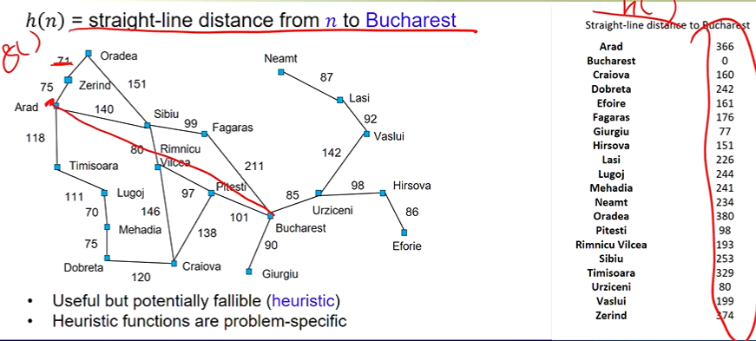

h(n) will be less than the real cost because it is a straight line.

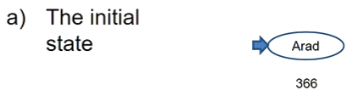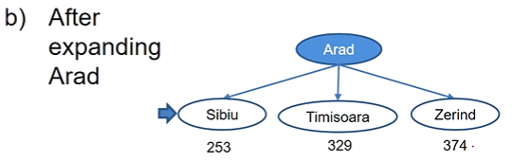

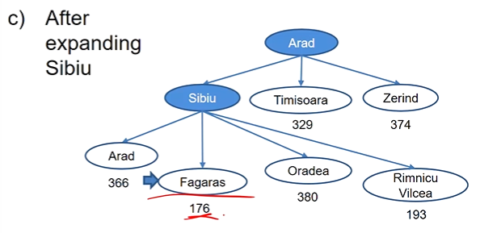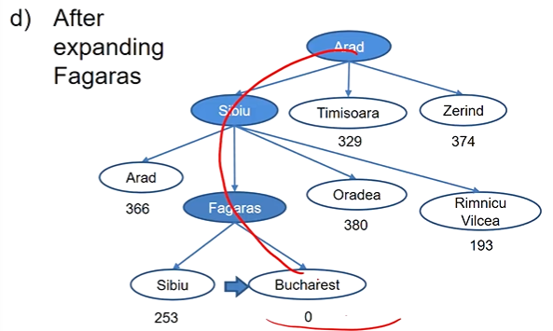

real cost = 140+99+211 = 450.

* This is not optimal.
* Also not complete:
  + 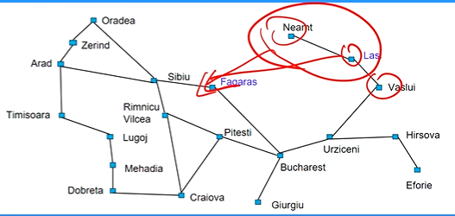
  + Infinite loop between Lasi and Nearnt is possible

|  |  |
| --- | --- |
| Struct Type | Priority queue (heuristic cost h(n)) |
| Complete | No |
| Time | O(bm) |
| Space | O(bm)(keeps all nodes in memory) |
| Optimal | No |

(worst case)

# INF | A * search

## Uniform-cost Search

* g(n): cost to reach n (Past Experience)
* optimal and complete, but can be very inefficient

## Greedy Search

* h(n): cost from n to goal (Future Prediction)
* neither optimal nor complete, but cuts search space considerably.

## Idea: combine greedy search with uniform-cost search.

## Evaluation function: f(n) = g(n) + h(n)

* f(n): estimated total cost of path through n to goal (Whole Life)
  + g(n): backward cost, cumulative cost of current node from the root
  + h(n): forward cost, estimate of the distance of current node from goal
  + If g = 0 --> greedy search If h = 0 --> UCS

Function A* Search(problem) returns solution

Return Best-First-Search(problem, g+h)

|  |  |
| --- | --- |
| Struct Type | Priority queue (cost g(n)+h(n)) |
| Complete | Yes |
| Time | Depends on the heuristic |
| Space | O(bd) as it stores all generated nodes in memory. |
| Optimal | Yes |

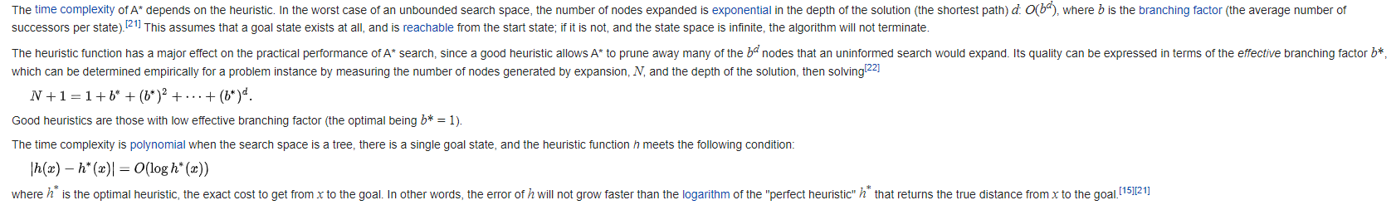

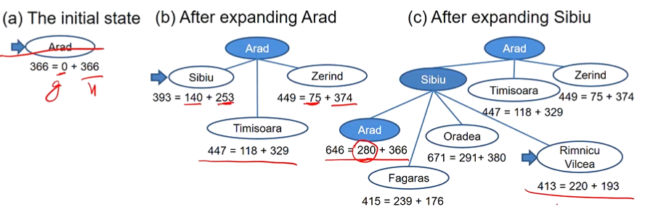

the second Arad is 280 because it is the g(n) to go from Arad to Sibiu then back to Arad

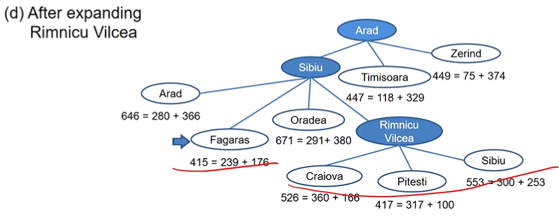

after Rimnicu, we realise Fagaras has a smaller value, so we expand Fagaras

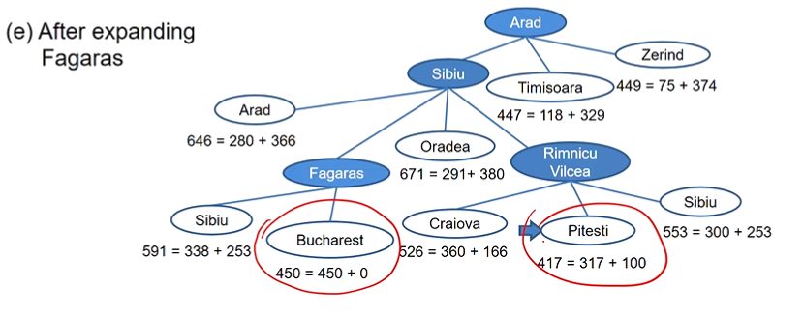

expand Pitesi because it has smaller f(n). Don’t care that Bucharest is our goal. Recall that we only do goal test when deciding to expand a node.

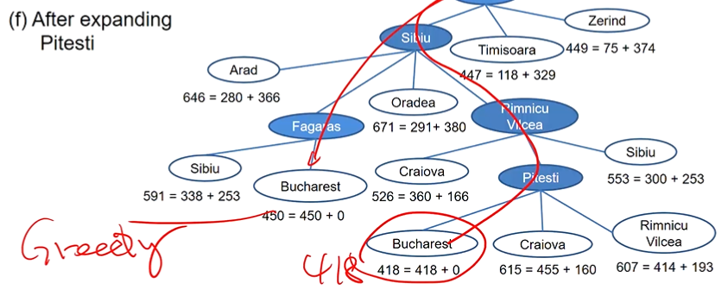

A* is optimal. Unlike Greedy

Example: route-finding

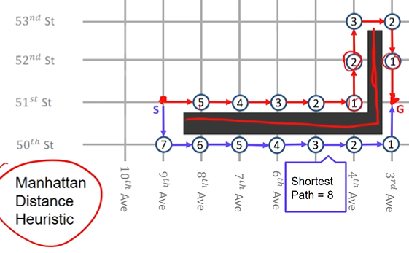

Manhattan Distance Heuristic = x displacement + y displacement

## GREEDY SEARCH

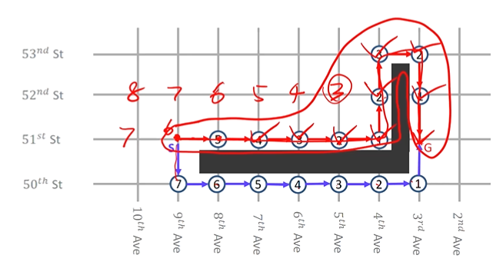

Total cost of path = 10. Not optimal but efficient

By constantly seeking to just optimise at the local level, it can take an overall longer path.

## UCS

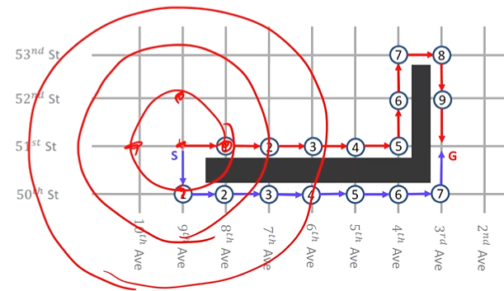

Total cost of path = 8. Optimal but inefficient

## A*

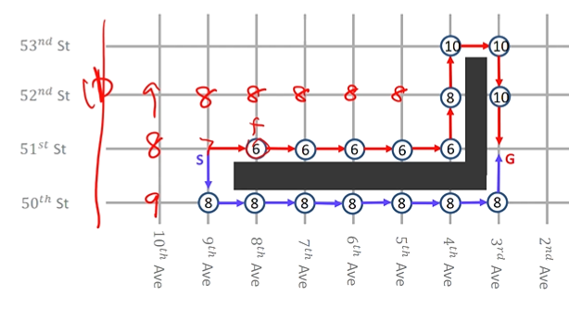

Better than UCS since it does not expand nodes going the wrong direction, and yet can find optimal path

CZ1115 Lecture FOUR

CONSTRAINT SATISFACTION, GAME PLAYING

# Constraint Satisfaction Problem (CSP)

## Goal: discover some state that satisfies a given set of constraints

Examples:

* Assignment problems e.g. who teaches what class
* Timetabling problems e.g. which class is offered when and where?
* Hardware configuration e.g. motherboard
* Transporation scheduling
* Factory scheduling
* Floor-planning

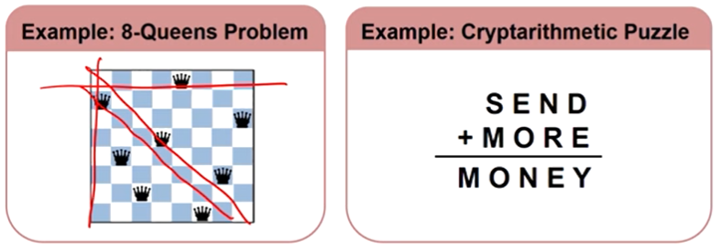

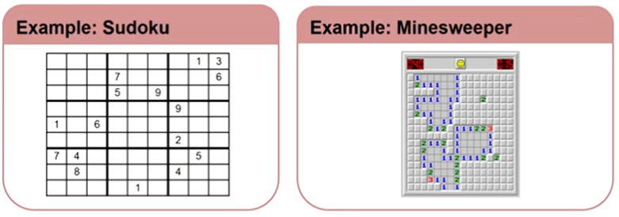

# [CSP] State, Actions, Goal

## State: defined by the values assigned so far from the domain to some or all of the variables.

* assignment that does not violate any constraints is called a consistent/legal assignment.

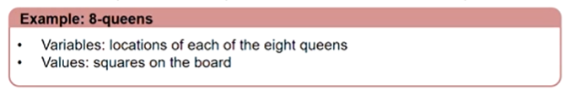

## Initial state: all variables unassigned

## Actions: assign a value to an unassigned variable

## Goal test: all variables are assigned and no constraints are violated.

* Solution: assignment with every variable given a value (complete) and the assignment satisfies all the constraints.
* Note that there might be multiple solutions, but we just want to find one. One we do the goal test and find out it’s a goal state, the end.

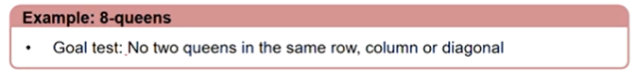

# [CSP] Variables, Domains, Constraints

## Variables: what you see

## Domains: what they can possibly contain/represent

## Constraints: the conditions that they must fulfill

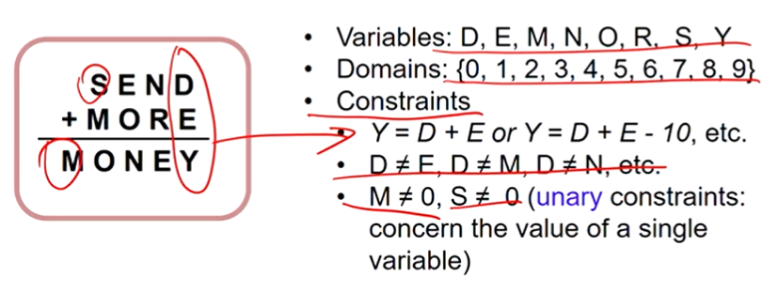

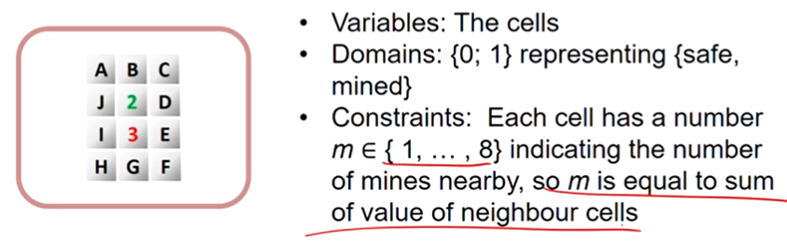

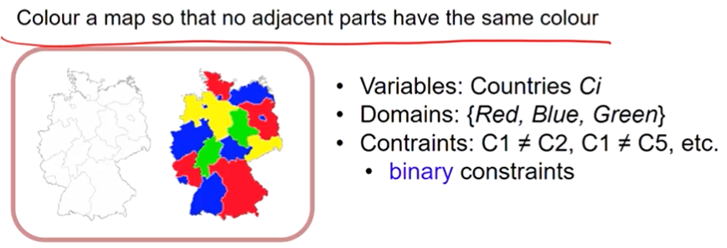

# Question: How to represent constraints?

## Answer: Explicitly (e.g. D != E). Implicitly: Use a function to test for constraint satisfaction

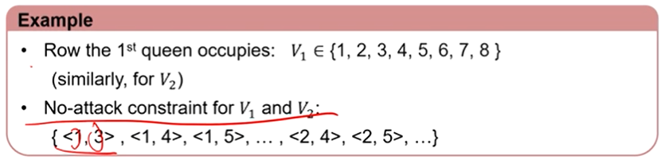

Combined Example:

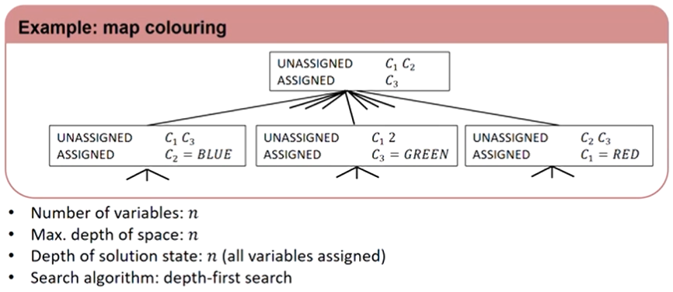

# Backtracking Search

## Do not waste time searching when constraints have already been violated

1. Before generating successors, check for constraint violations
2. If yes, backtrack to try something else

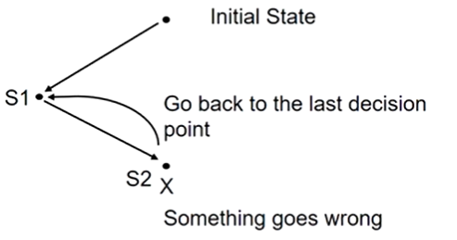

Example:

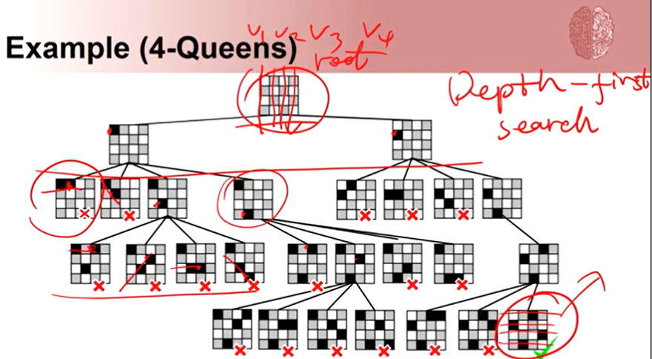

# Heuristics for CSPs

* Plain backtracking is an uninformed algorithm.
* More intelligent search takes into consideration
  + Which variable to assign next
    - e.g. instead of v1 --> v2 --> v3 --> v4, can go another way
  + What order of the values in the domain to try for each variable
    - e.g. instead of filling from the top down for each v, can try another filling method
  + Implications of current variable assignments for the other unassigned variables: forward checking and constraint propagation.

## Constraint propagation: propagating the implications of a constraint on one variable onto other variables

* Cost of doing this extra computation is very small compared to searching the extra nodes

Example: Queen problem

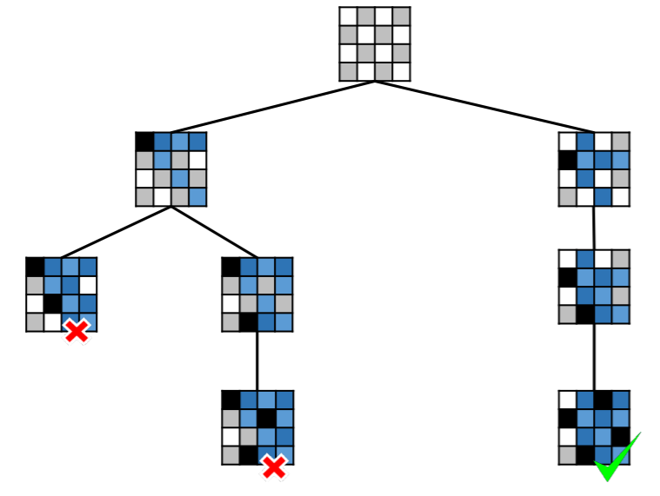

* Only need to expand 8 nodes (to achieve 8 states). Contrast to the previous method without constraint propagation which requires 27 nodes (states):
  + 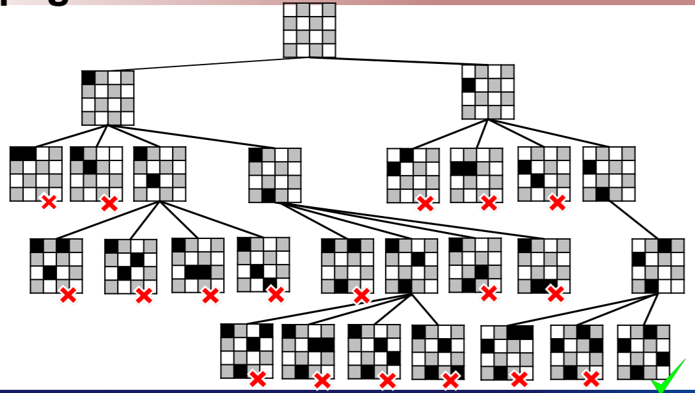

Example: map colouring

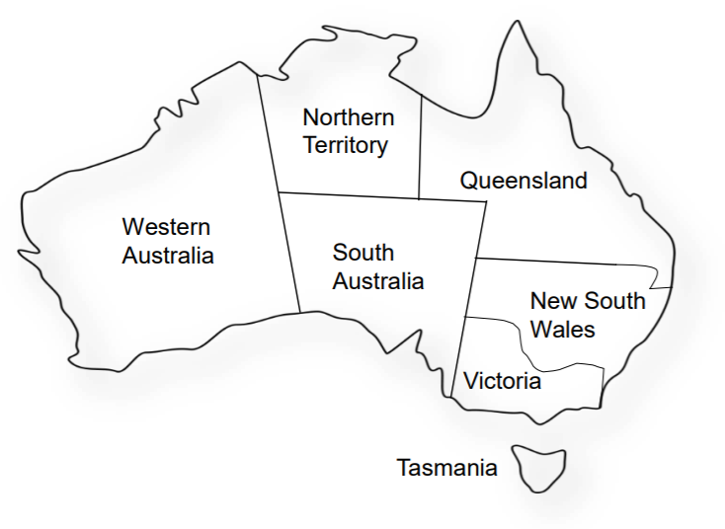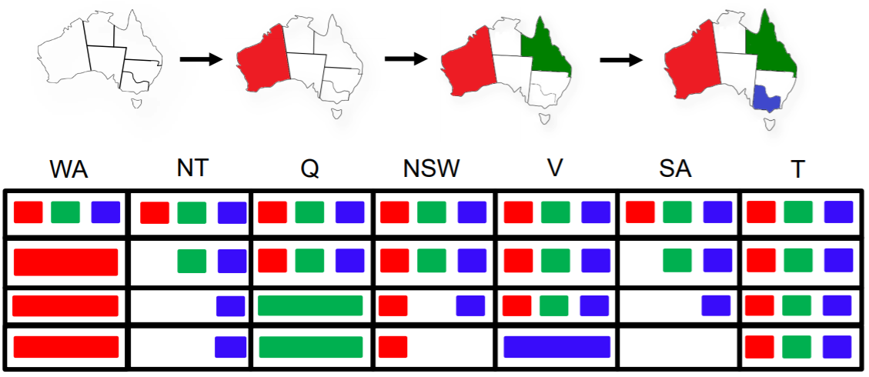

question: why start at WA?

answer: you don’t have to. In fact it is better to start at SA.

# Most Constrained Variable

## Or minumum remaining values (MRV) heuristic.

* To reduce the branching factor on future choices by selecting the variable that is involved in the largest number of constraints on unassigned variables.

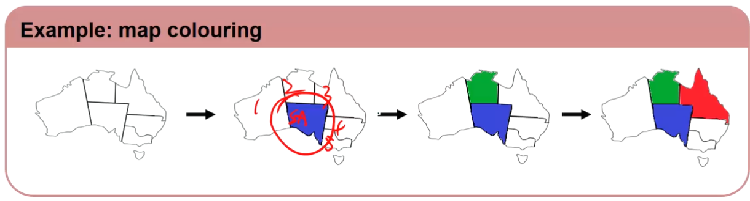

# Least Constraining Value (to assign the variable)

* Opposite idea: choose the value that leaves maximum flexibility for subsequent variable assignments

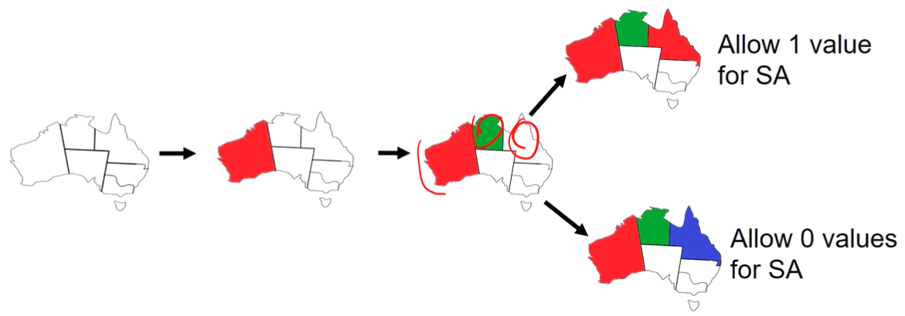

# Min-Conflicts Heuristic

* A local heuristic search method for solving CSPs. More like local search

1. Start with an initial assignment where all variables are assigned
2. Select a variable that is currently in violation of a constraint
3. Reassign it to the value that minimises the number of violated constraints
4. May not reach Goal State

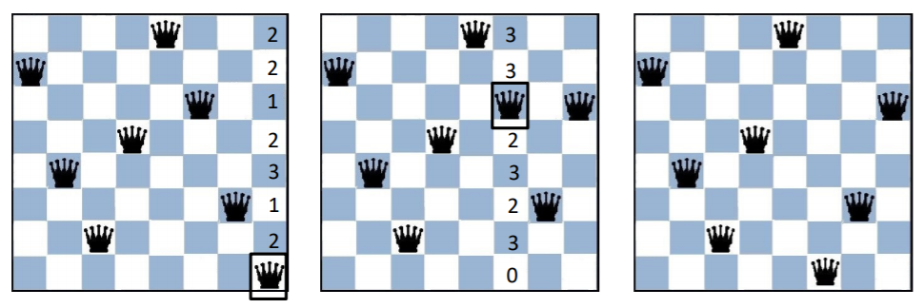

# Games as Search Problems

## Abstraction

* Ideal representation of real world problems
  + e.g. board games, chess, go, etc. as an abstraction of war games
  + Perfect information, i.e. fully observable
* Accurate formulation: state space representation

## Uncertainty

* Accounts for the existence of hostile agents (players)
* Other agents acting so as to diminish the agent's well-being
* Uncertainty (about other agents' actions):
  + not due to the effect of non-deterministic actions
  + not due to randomness
  + Hence, contingency problem

## Complexity

* Games are abstract but not simple
  + e.g. chess: average branching factor = 35, game length > 50. Hence, complexity = 3550(only 1040 for legal moves)
* Games are usually time limited
  + Complete search (for the optimal solution) not possible. Hence, uncertainty on actions’ desirability
  + Search efficiency is crucial

Perfect info: each player has complete information about his opponent’s position and about the choices available.

|  |  |  |
| --- | --- | --- |
|  | Deterministic | Chance |
| Perfect information | Chess, Checkers, Go, Othello | Backgammon, Monopoly |
| Imperfect information |  | HARDEST  Bridge, Poker, Scrabble, Nuclear war |

* Initial state: initial board configuration and indication of who makes the first move
* Operators: legal moves
* Terminal test: determines when the game is over
  + states where the game has ended: terminal states
* Utility function (payoff function): returns a numeric score to quantify the outcome of a game

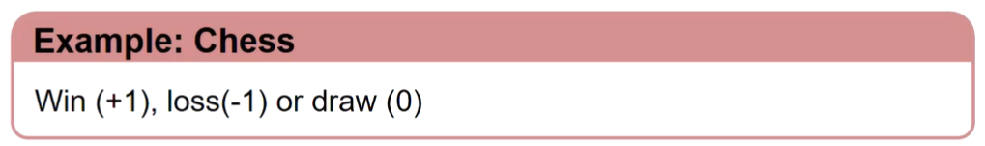

# Game Tree for Tic-Tac-Toe

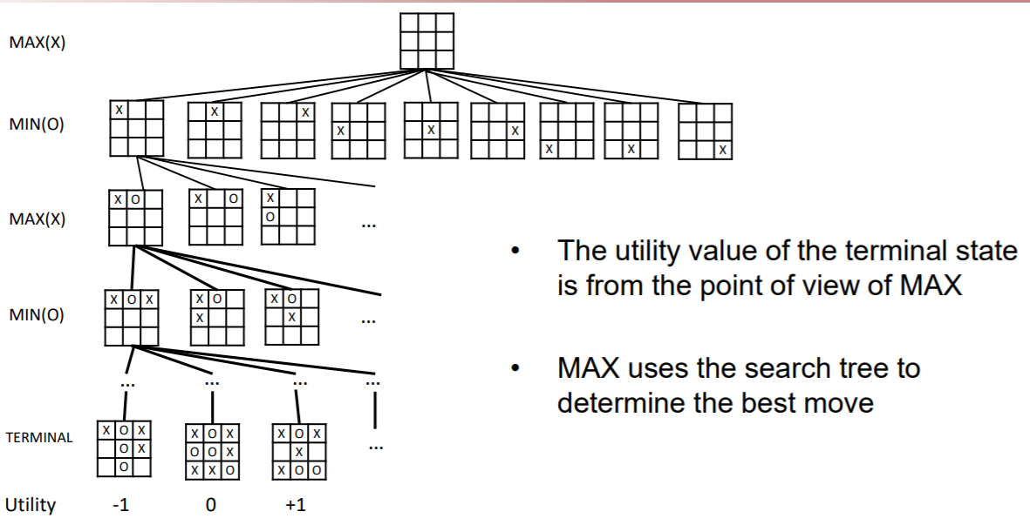

## What search strategy?

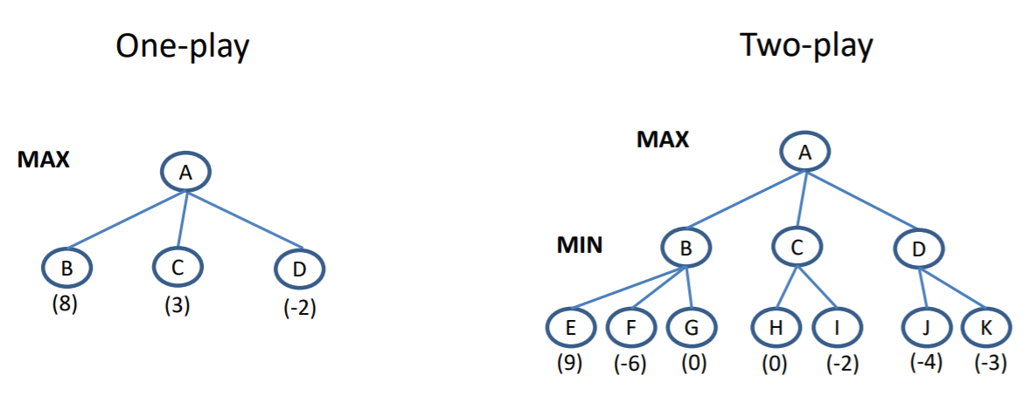

* Search strategy: find a sequence of moves that leads to a terminal state (goal)

# Minimax search strategy

## kinda like backtracking

* Two players: MAX and MIN
* Choose move with best achievable payoff against best play: Maximise one's own utility and minimise the opponent's
* Assumption is that the opponent does the same: Since the game is a zero-sum game, we assume they will choose a move that has the most negative utility for us (most positive utility for them)
  + MAX tries to max the utility, assuming that MIN will try to min it

1. Generate the entire game tree down to terminal states
2. Calculate utility
   1. Assess the utility of each terminal state
   2. Determine the best utility of the parents of the terminal state
   3. Repeat the process for their parents until the root is reached
3. Select the best move (i.e. the move with the highest utility value) for node-1 given the assumption

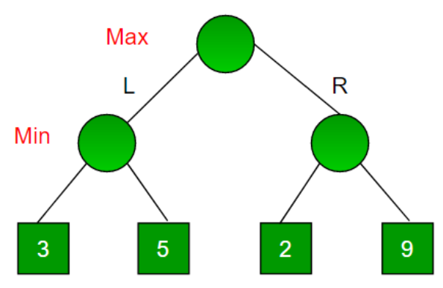

we would choose left instead of right, due to the assumption that MIN will choose the worst utility for us.

## Perfect decisions: no time limit is imposed. Generate the complete search tree:

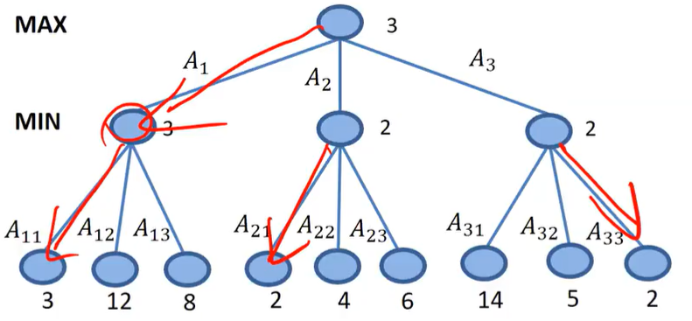

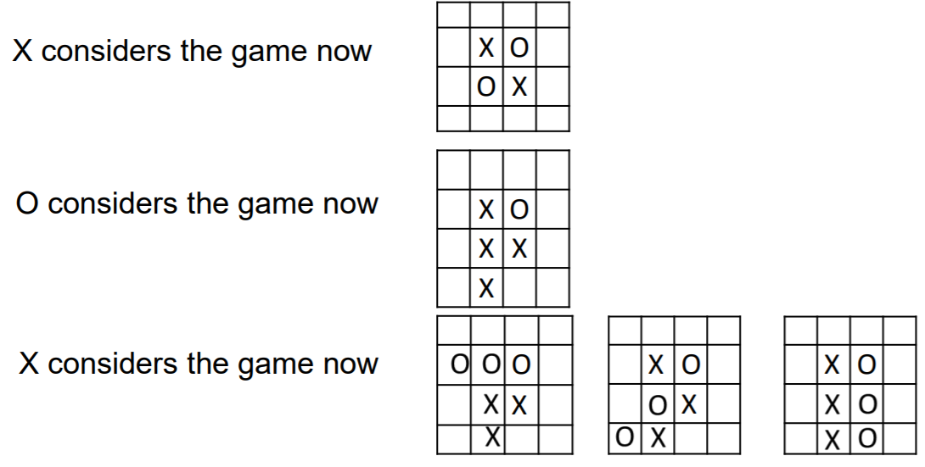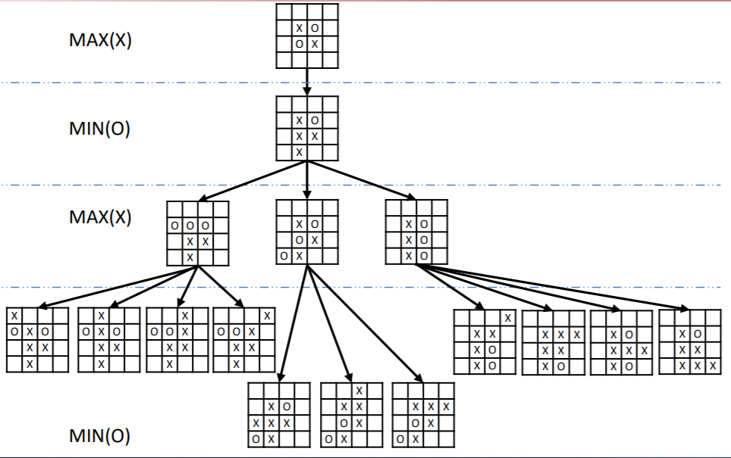

## Imperfect State

* For chess, branching factor ≈ 35, each player typically makes 50 moves --> for the complete game tree, need to examine 35100 positions
* Time/space requirements --> complete game tree search is intractable --> impractical to make perfect decisions
* Hence, modifications to minimax algorithm:

1. Replace utility function by an estimated desirability of the position
   1. Evaluation function: return an estimate of the expected utility of the game from a given position.
   2. This evaluation function is provided by domain experts (case-specific)
      1. e.g. value network for Go
2. Partial tree search
   1. Replace terminal test by a cut-off test
      1. e.g. depth limit